Project Report: Smart Sorting Transfer Learning for Identifying Rotten Fruits and Vegetables

INTRODUCTION
Project Title:
Smart Sorting Transfer Learning for Identifying Rotten Fruits and Vegetables
Team Members:

Team Leader : UMAMAHESWARI.M
Team member: DURGA BHAVANI.P
Team member: MUNEESWAR.M

PROJECT OVERVIEW
Purpose:

This project aims to reduce food waste and improve quality assurance in agricultural supply chains by using AI to automatically detect rotten fruits and vegetables.

Features:
Image upload feature
AI model for freshness classification Web-based user interface
Real-time prediction and result display

ARCHITECTURE
Frontend:

Developed using HTML, CSS, and JavaScript (served from static folder) for a responsive UI. HTML templates are stored in the templates folder and rendered using Flask.

Backend:
Built with Python using Flask. Handles routing, model inference, and image processing. Core logic resides in app.py, and the CNN model logic is encapsulated in cnn.py.

Database:

Currently, no persistent database is used. Optionally, a lightweight database like SQLite or MongoDB can be integrated for logging predictions.

SETUP INSTRUCTIONS
Prerequisites:
Python 3.x Flask
TensorFlow/Keras Installation:
Clone the repository: git clone https://github.com/your-repo.git Navigate to the project directory: cd your-repo
Install dependencies: pip install -r requirements.txt Place your model file as model.h5 in the project root
Ensure folders media, static, and templates are properly populated Run the app: python app.py

FOLDER STRUCTURE

media/ – contains uploaded images
static/ – contains CSS and JavaScript files templates/ – contains HTML files rendered by Flask app.py – main Flask application file
cnn.py – defines the model loading and prediction logic

model.h5 – pre-trained CNN model

RUNNING THE APPLICATION

Flask Backend (also serves frontend):
Run the following command:
python app.py
Navigate to http://127.0.0.1:5000 in your browser to use the app.

API DOCUMENTATION
POST /predict Response:
{
"status": "success", "prediction": "Fresh"
}

AUTHENTICATION
Currently, this project does not use authentication. It is planned as a future enhancement.

USER INTERFACE
Upload Image Page Prediction Result Display
It should be and image with a bar to select images once you selectd an another press predict and you will see results

TESTING
Strategy:
Manual testing of UI interactions
Unit testing using unittest for model functions

Accuracy testing using test datasets

SCREENSHOTS OR DEMO
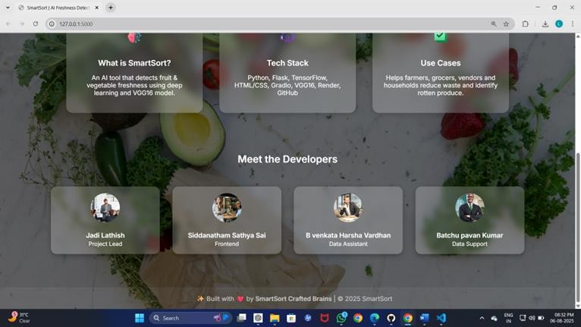
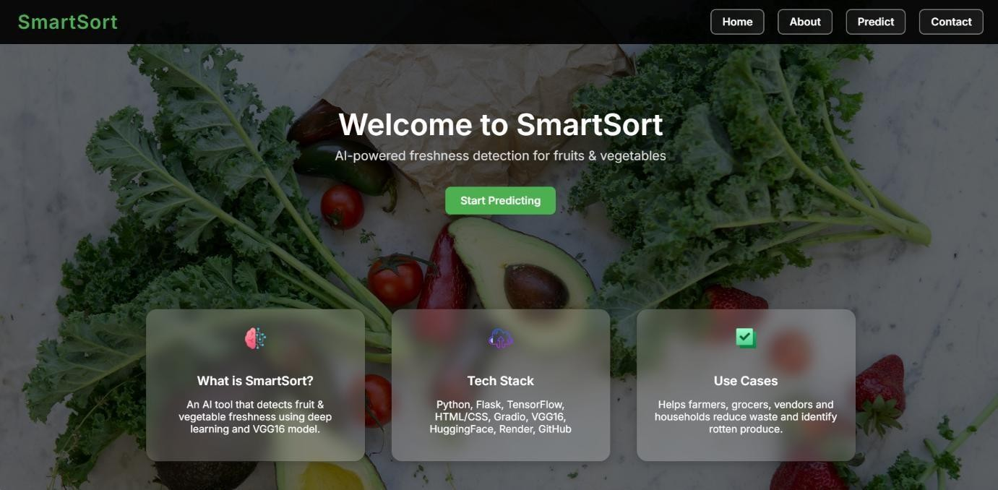

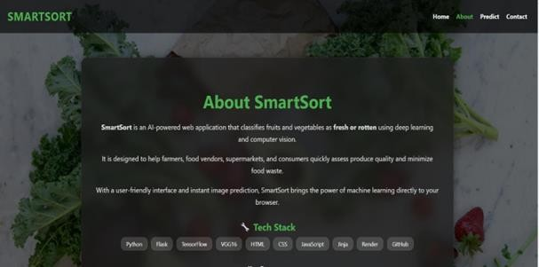
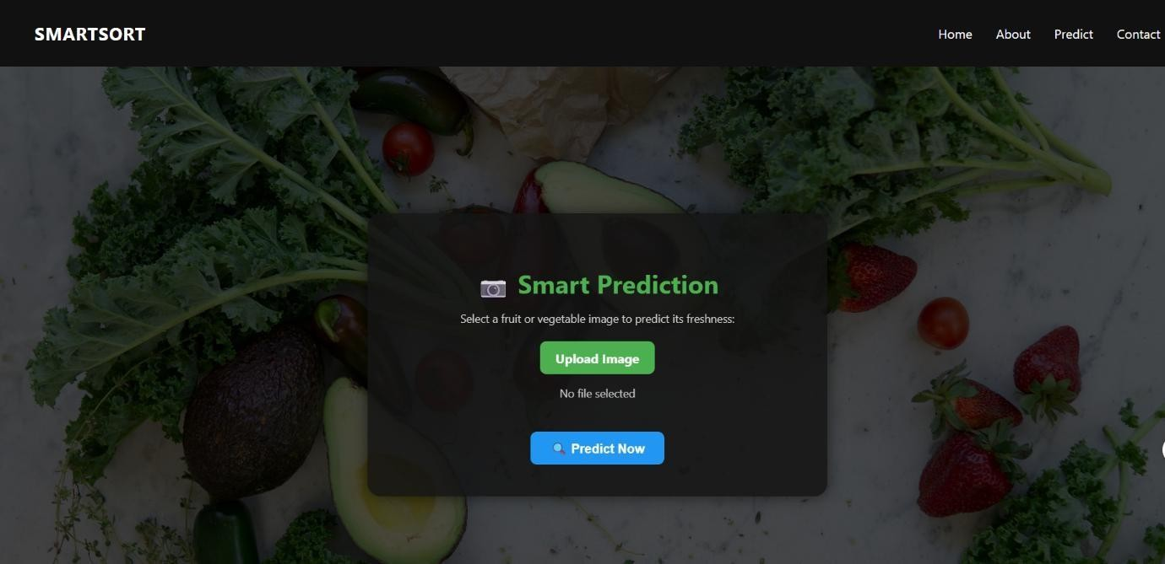
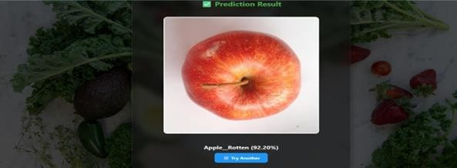

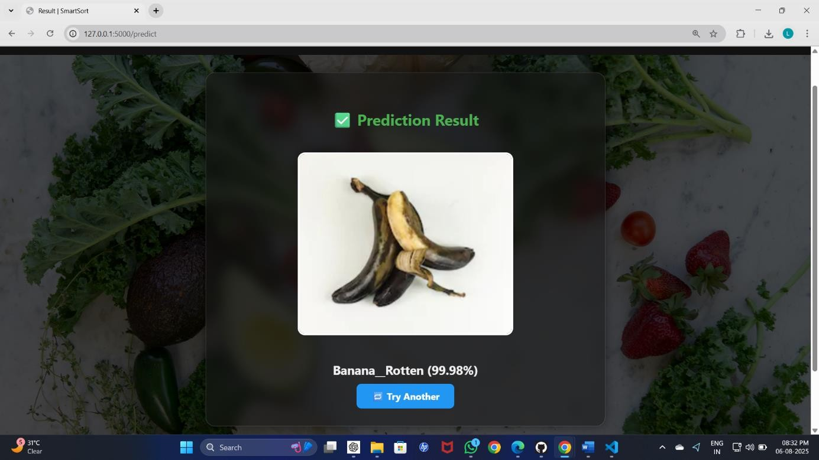

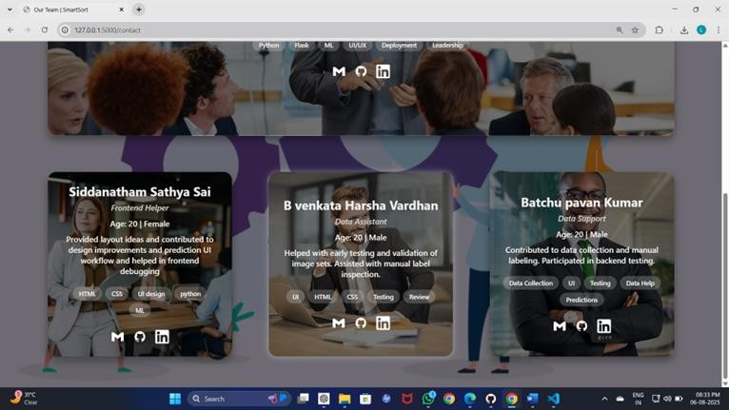

- KNOWN ISSUES
  - Image quality affects prediction accuracy
  - Limited to trained categories (only trained fruits/vegetables)
  - No user login system yet

FUTURE ENHANCEMENTS

  - Add user authentication system
  - Enable drag-and-drop upload
  - Train model on more fruits/vegetables
  - Develop mobile app version

